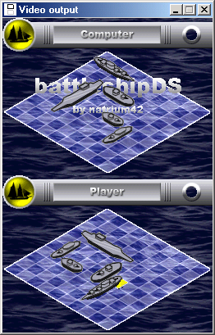
Dualis is a plugin-based DS emulator for x86/Win32 computers. It is written in x86 assembly and C++.

